package game;

import java.util.Random;

import java.util.Scanner;

public class StartGame {

public static void gameWin (int announceWin) { // declare winner

if (announceWin == 1) {

System.out.println("Congratulations! You won!");

}

else if (announceWin == 0) {

System.out.println("Better luck next time!");

}

System.exit(0); // program exits

}

public static int matchStart(int player, int cpu, char[][] board) { // player 1, player 2

int i;

int j;

int k = 0;

int checkForWin = 0;

for (i = 0; i < 3; ++i) { // FIX: Player or CPU losing turns && Choosing a move

for (j = 0; j < 3; ++j){

k++;

if (k == player) {

if (board[i][j] != 'O') {

System.out.println("Illegal move.");

k = 10;

break;

}

else if ((k == player) && (board[i][j] != 'O')) {

board[i][j] = 'X';

k = 10;

break;

}

}

if (k == cpu) {

if (board[i][j] != 'X') {

System.out.println("Illegal move.");

k = 10;

break;

}

else if ((k == cpu) && (board[i][j] != 'X')) {

board[i][j] = 'O';

k = 10;

break;

}

}

}

if (k == 10) {

break;

}

}

// fix moves - certain moves are taken by the other player

System.out.println("\t|\t|\t");

System.out.println("\t|\t|\t");

System.out.println("____" + board[0][0] + "_______" + board[0][1] + "_______" + board[0][2] + "_____");

System.out.println("\t|\t|\t");

System.out.println("\t|\t|\t");

System.out.println("____" + board[1][0] + "_______" + board[1][1] + "_______" + board[1][2] + "_____");

System.out.println("\t|\t|\t");

System.out.println("\t|\t|\t");

System.out.println(" " + board[2][0] + " " + board[2][1] + " " + board[2][2]);

if (board[0][0] == 'X' && board[0][1] == 'X' && board[0][2] == 'X') {

checkForWin = 1;

gameWin(checkForWin);

}

else if (board[1][0] == 'X' && board[1][1] == 'X' && board[1][2] == 'X') {

checkForWin = 1;

gameWin(checkForWin);

}

else if (board[2][0] == 'X' && board[2][1] == 'X' && board[2][2] == 'X') {

checkForWin = 1;

gameWin(checkForWin);

}

else if (board[0][0] == 'X' && board[1][0] == 'X' && board[2][0] == 'X') {

checkForWin = 1;

gameWin(checkForWin);

}

else if (board[0][1] == 'X' && board[1][1] == 'X' && board[2][1] == 'X') {

checkForWin = 1;

gameWin(checkForWin);

}

else if (board[0][2] == 'X' && board[1][2] == 'X' && board[2][2] == 'X') {

checkForWin = 1;

gameWin(checkForWin);

}

else if (board[0][0] == 'X' && board[1][1] == 'X' && board[2][2] == 'X') {

checkForWin = 1;

gameWin(checkForWin);

}

else if (board[0][2] == 'X' && board[1][1] == 'X' && board[2][0] == 'X') {

checkForWin = 1;

gameWin(checkForWin);

}

else if (board[0][0] == 'O' && board[0][1] == 'O' && board[0][2] == 'O') {

checkForWin = 0;

gameWin(checkForWin);

}

else if (board[1][0] == 'O' && board[1][1] == 'O' && board[1][2] == 'O') {

checkForWin = 0;

gameWin(checkForWin);

}

else if (board[2][0] == 'O' && board[2][1] == 'O' && board[2][2] == 'O') {

checkForWin = 0;

gameWin(checkForWin);

}

else if (board[0][0] == 'O' && board[0][1] == 'O' && board[0][2] == 'O') {

checkForWin = 0;

gameWin(checkForWin);

}

else if (board[1][0] == 'O' && board[1][1] == 'O' && board[1][2] == 'O') {

checkForWin = 0;

gameWin(checkForWin);

}

else if (board[2][0] == 'O' && board[2][1] == 'O' && board[2][2] == 'O') {

checkForWin = 0;

gameWin(checkForWin);

}

else if (board[0][0] == 'O' && board[1][1] == 'O' && board[2][2] == 'O') {

checkForWin = 0;

gameWin(checkForWin);

}

else if (board[0][2] == 'O' && board[1][1] == 'O' && board[2][0] == 'O') {

checkForWin = 0;

gameWin(checkForWin);

}

return -1;

}

public static void displayBoard(int player) { // display board and introduction to game

char[] board = new char[9];

int i;

if (player == 1) {

for (i = 0; i < board.length; ++i) {

board[i] = 'X';

}

}

System.out.println("\t|\t|\t");

System.out.println("\t|\t|\t");

System.out.println("____" + board[0] + "_______" + board[1] + "_______" + board[2] + "_____");

System.out.println("\t|\t|\t");

System.out.println("\t|\t|\t");

System.out.println("____" + board[3] + "_______" + board[4] + "_______" + board[5] + "_____");

System.out.println("\t|\t|\t");

System.out.println("\t|\t|\t");

System.out.println(" " + board[6] + " " + board[7] + " " + board[8]);

}

public static void main(String[] args) {

final int ROWS = 3; // Array size for rows

final int COLUMNS = 3;// Array size for columns

char[][] board = new char[ROWS][COLUMNS]; // array initialized

Scanner console = new Scanner(System.in);

Random randGen = new Random();

int game;

int cpu;

int i;

int j;

System.out.println("Welcome to Tic-Tac Toe!");

System.out.println("Are you ready to start? Press 1 to start, you will play as X.");

game = console.nextInt(); // user input for game start - if not 1, program exits

if (game == 1) {

displayBoard(game);

for (i = 1; i < 10; ++i) {

System.out.println("Your move on the board from left to right, 1-3 (top), 4-6 (middle), 7-9 (bottom)");

game = console.nextInt();

cpu = randGen.nextInt(10) + 1;

if (game == cpu) {

cpu = randGen.nextInt(10) + 1;

}

if (matchStart(game,cpu,board) == -1) {

i = i - 1;

}

}

}

}

}

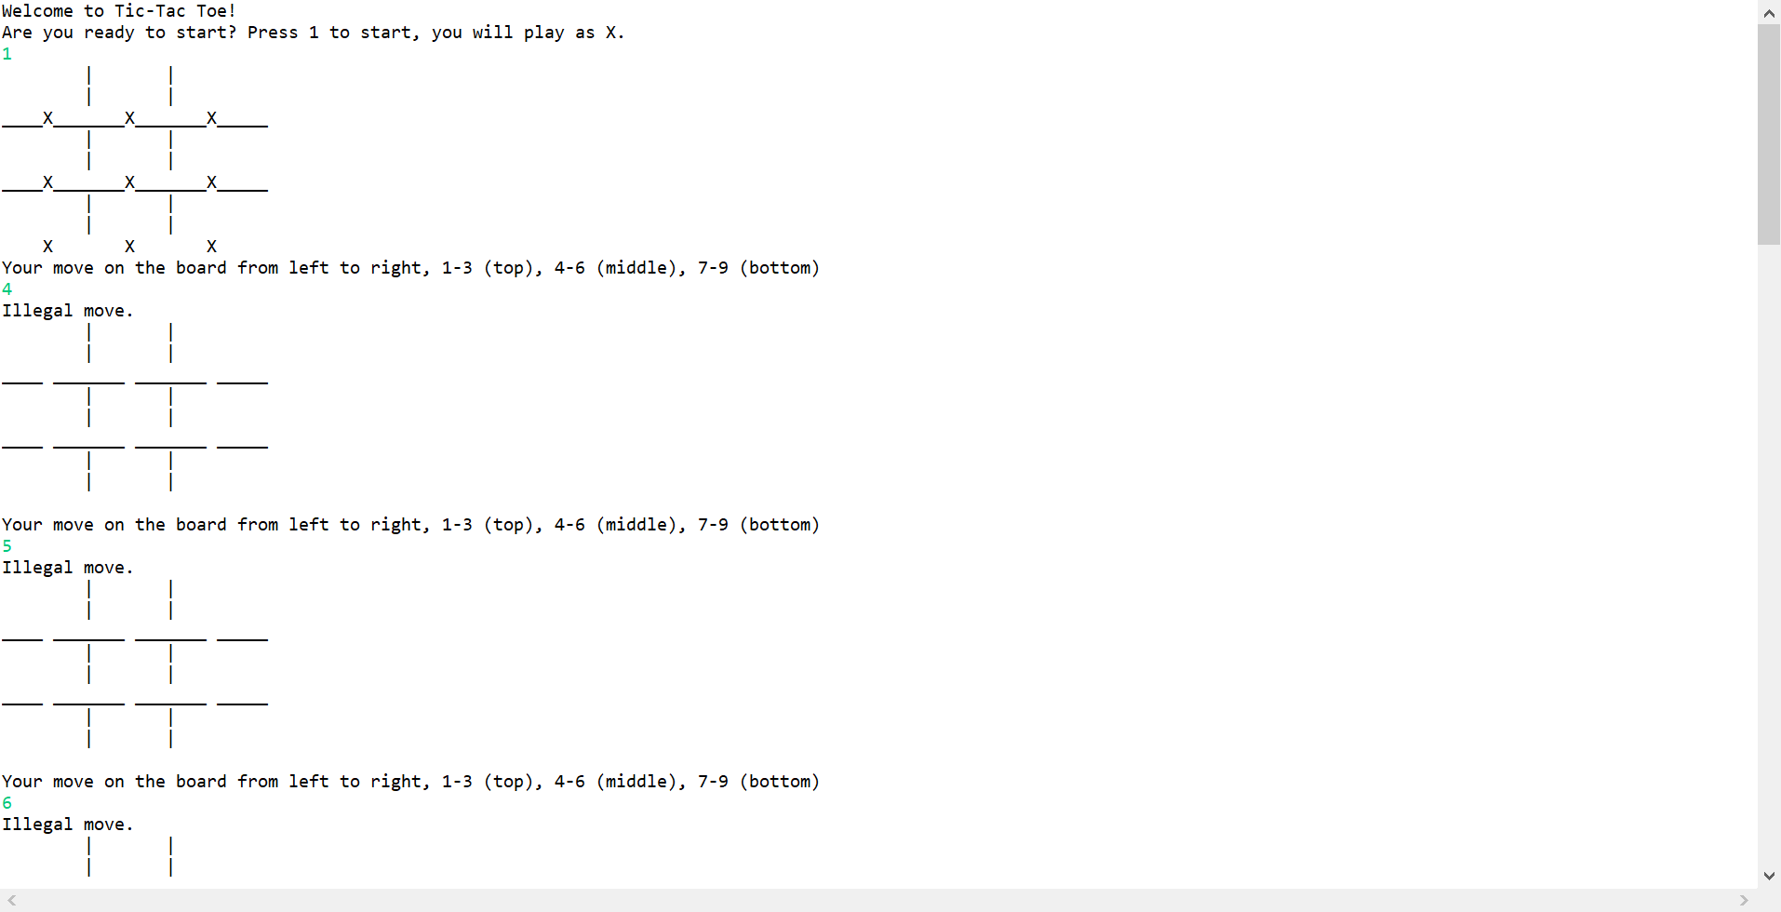

Part I – The documentation for the game is represented here - <https://www.exploratorium.edu/brain_explorer/tictactoe.html>

Part II – Using the wrong operator can be an issue, especially when it comes down to whether the variable has been incremented before the loop has started or after the loop has begun, based on the curly brackets that indicate the block of code.

For example, in this block of code, a prints out two different values for the code:

{

int a = 0;

int b = 0;

a = b++ + b;

System.out.println(“” + a + “,” + b + “”); // outputs 0, 1

a = 0;

b = 0;

a = ++b + b;

System.out.println(“” + a + “,” + b + “”); // outputs 2, 1

}

Part III - Whenever static variable is declared in java it belongs to class not the object. The keyword static indicates that the particular member belongs to a type itself, like an entity of its own for OOP (Object Oriented Programming.